**QUESTIONS IN MONGODB DATABASE**

**EXAMPLE OF LEADERBOARD DATABASE**

**USERS DATABASE AFTER REGISTRATION**

**USER RULES**

**ADMIN RULES**

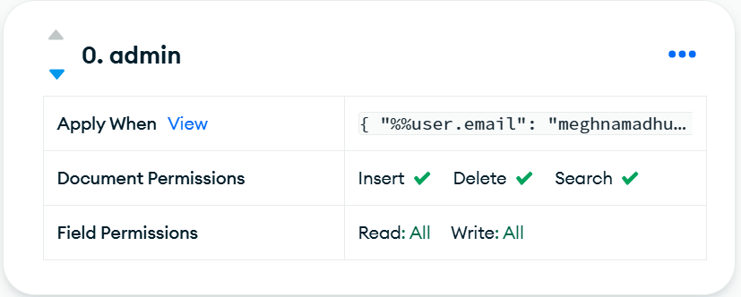

**AUTHENTICATION**

**(Email, Password authentication)**

**DATABASE ACCESS**

